PREDICTING THE ENERGY OUTPUT OF WIND TURBINE BASED ON WEATHER CONDITION

SOLUTION ARCHITECTURE

**MACHINE LEARNING ALGORITHM**

Data processing modules

*PREPAREDDATA*

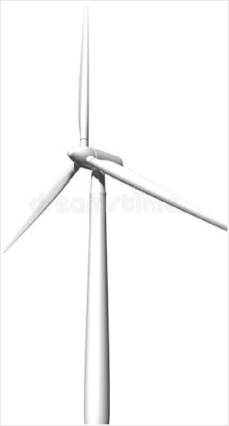

SCADA

RAW DATA

Data

**10001**

**100**



Data preprocessing

FEATURE EXTRACTION APPLY ALGORITHM

***MODEL***

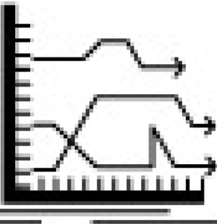 

***PREDICTIVE MAINTENANCE***

***BUILDENSEMBLE***

***MODEL***

***MODEL***

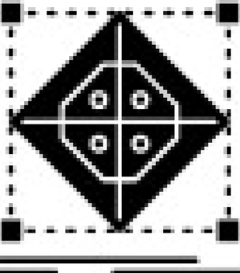***SELECTION***